Running Wireshark

Running Wireshark

When you run the Wieshark program, you'll get a startup screen, as shown below:

ake a look at the upper left hand side of the screen - you'll see an "Interface list”. This is the list of network interfaces on your computer. Once you choose an interface, Wireshark will capture all packets on that interface. In the example above, there is an Ethernet interface (Gigabit network Connection) and a wireless interface ("Microsoft”).

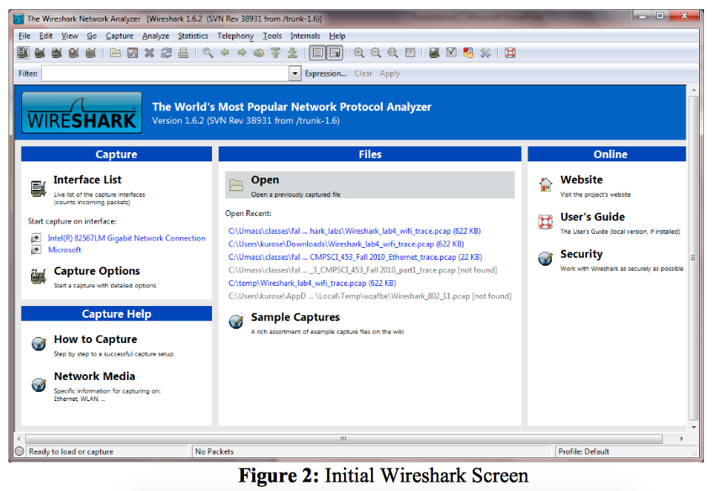

If you click on one of these interfaces to start packet capture (i.e., for Wireshark to begin capturing all packets being sent to/from that interface), a screen like the one below will be displayed, showing information about the packets being captured. Once you start packet capture, you can stop it by using the Capture pull down menu and selecting Stop.

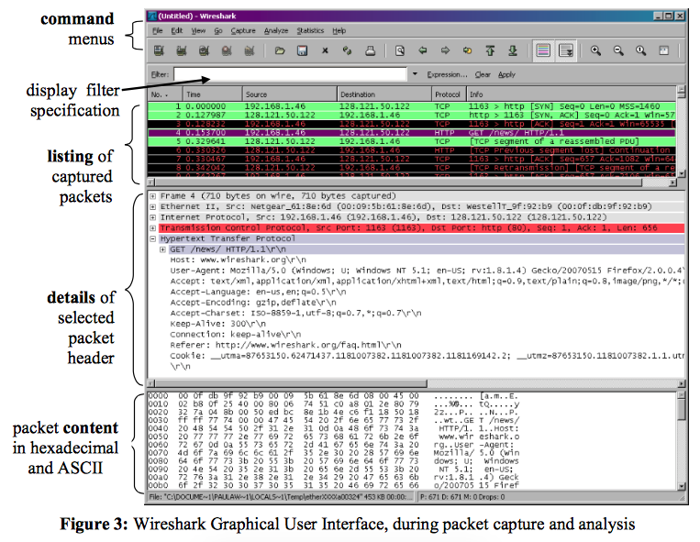

The Wireshark interface has five major components:

* The **command menus**are standard pulldown menus located at the top of the window. Of interest to us now are the File and Capture menus. The File menu allows you to save captured packet data or open a file containing previously captured packet data, and exit the Wireshark application. The Capture menu allows you to begin packet capture.
* The **packet-listing window**displays a one-line summary for each packet captured, including the packet number (assigned by Wireshark; this is *not*a packet number contained in any protocol's header), the time at which the packet was captured, the packet's source and destination addresses, the protocol type, and protocol-specific information contained in the packet. The packet listing can be sorted according to any of these categories by clicking on a column name. The protocol type field lists the highest-level protocol that sent or received this packet, i.e., the protocol that is the source or ultimate sink for this packet.
* The **packet-header details window**provides details about the packet selected (highlighted) in the packet-listing window. (To select a packet in the packet- listing window, place the cursor over the packet's one-line summary in the packet-listing window and click with the left mouse button.). These details include information about the Ethernet frame (assuming the packet was sent/received over an Ethernet interface) and IP datagram that contains this packet. The amount of Ethernet and IP-layer detail displayed can be expanded or minimized by clicking on the plus minus boxes to the left of the Ethernet frame or IP datagram line in the packet details window. If the packet has been carried over TCP or UDP, TCP or UDP details will also be displayed, which can similarly be expanded or minimized. Finally, details about the highest-level protocol that sent or received this packet are also provided.
* The **packet-contents window**displays the entire contents of the captured frame, in both ASCII and hexadecimal format.
* Towards the top of the Wireshark graphical user interface, is the **packet display filter field,**into which a protocol name or other information can be entered in order to filter the information displayed in the packet-listing window (and hence the packet-header and packet-contents windows). In the example below, we'll use the packet-display filter field to have Wireshark hide (not display) packets except those that correspond to HTTP messages.